Elektronski fakultet jun 2018

PISMENI ISPIT IZ ENGLESKOG JEZIKA I

Ime i prezime: ___________________________ broj indeksa: ________

- What is computer architecture?

- Down below is a complex system that you need to describe:

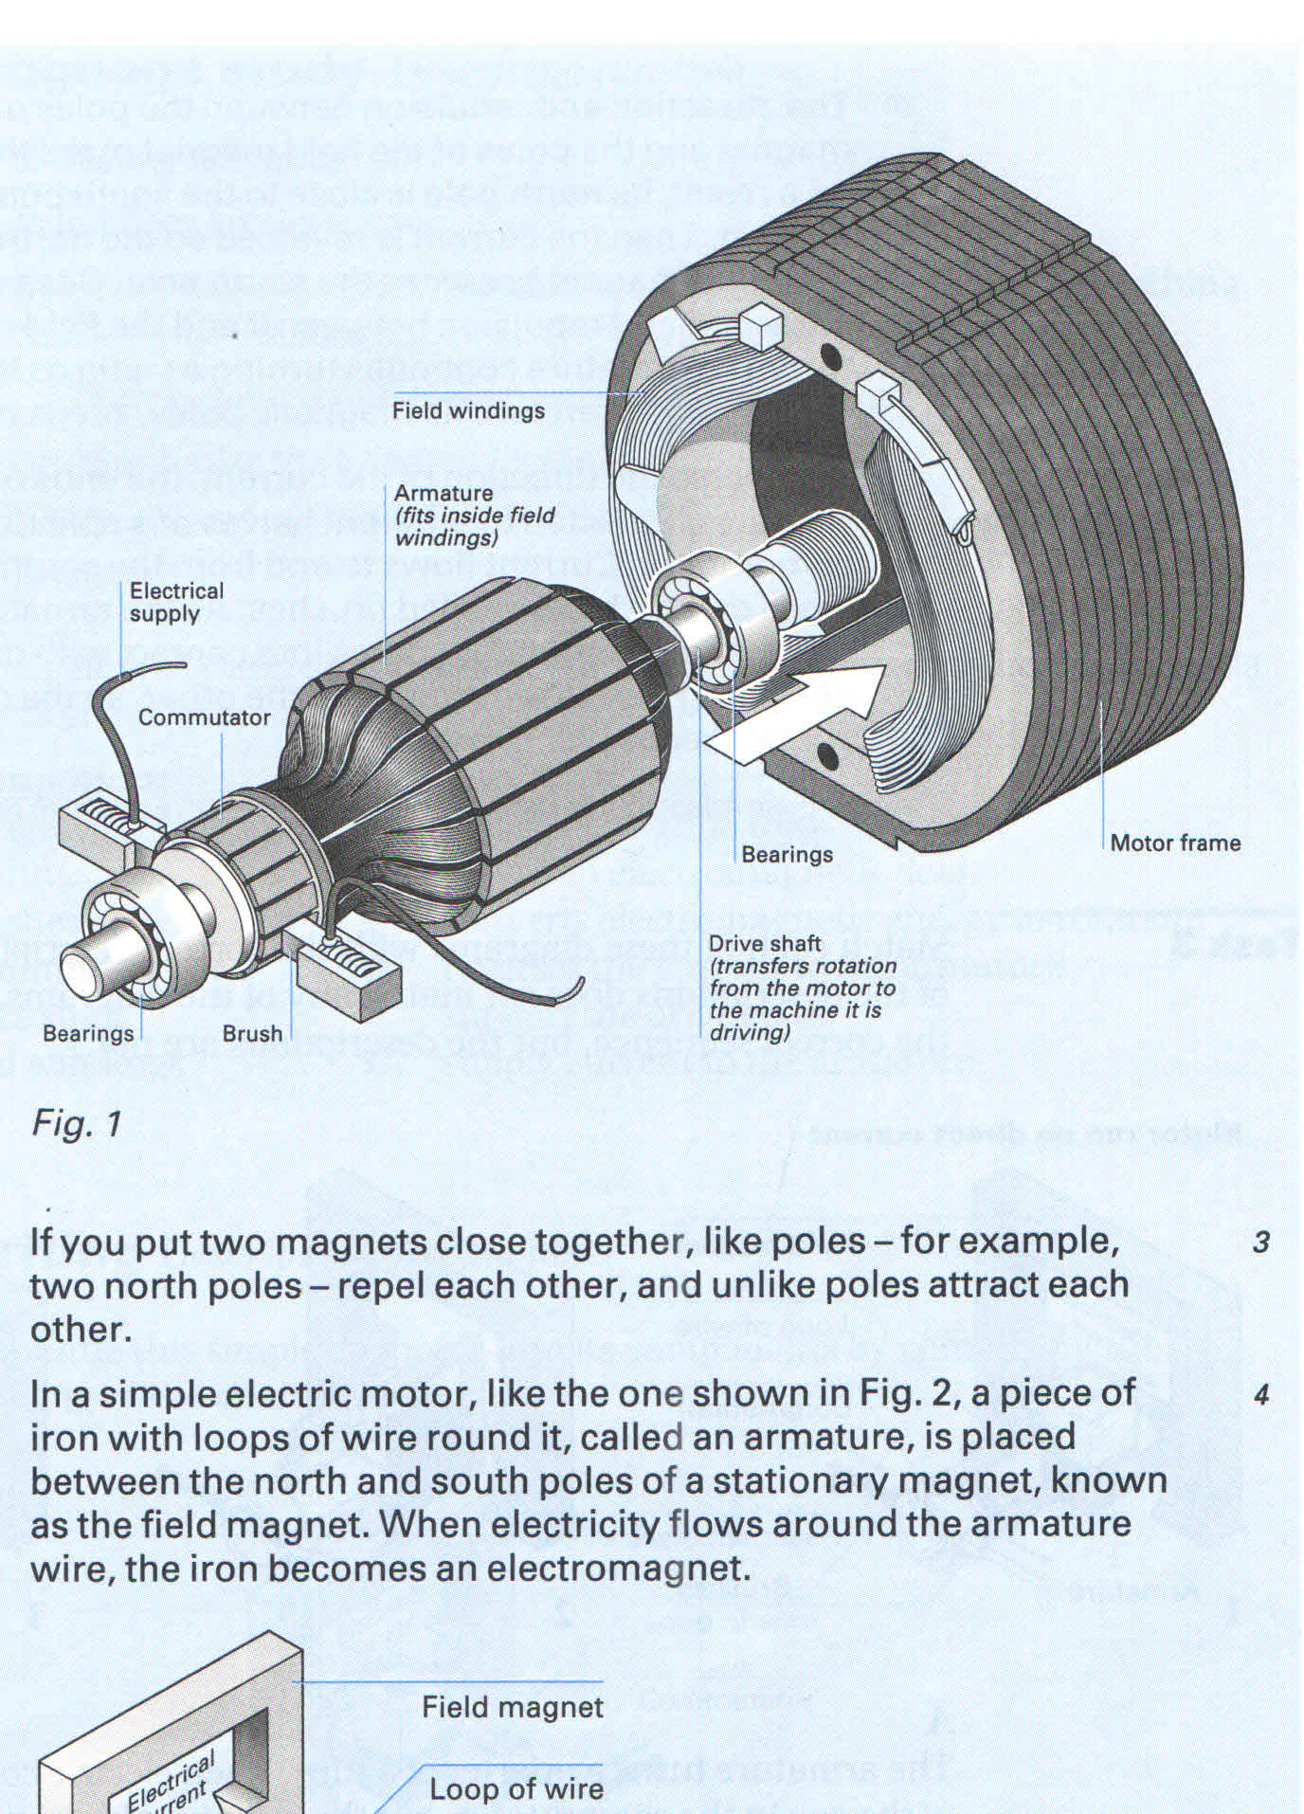

- Complete the sentences using the passive form of the verb in brackets:

- Microprocessors (make) _____________ of silicon.
- Call centres (use) ____________ to deal with telephone enquiries.
- In recent years, most mobile phones (equip) ____________ with Bluetooth.
- GPS (develop) __________ in the 1970s as a military navigation system.
- Sorry about the mess – the computers (replace) _____________ at the moment.
- In the near future, the Internet (access) ___________ more frequently from PDAs and mobile phones than from desktop computers.
- Networks (can connect) _____________ via satellite.
- I had to use my laptop this morning while my PC (fix) ___________.

- Complete with underlying the correct words:
1. … there’s a setting on the GPS that allows/prevents it to detect the movement.
2. … an alarm sounds to warn you, and allows/prevents the boat from drifting unnoticed.
3. … and enables/ensures that you don’t lose track of where you were, which then enables/ensures you to turn round and come back to the same point.

Complete with an allowing or preventing verb:
The core function of your GPS receiver is to ____________ you to locate your precise geographical position. To _______________ the device to function, it receives at least three signals simultaneously from the GPS constellation – 30 dedicated satellites which ___________ receivers to function anywhere on earth. To ___________ extremely precise positioning and ____________ errors from occurring due to external factors, this device is designed to receive four separate signals (enhanced system accuracy).

- Describe the graph below in as many details as you can:
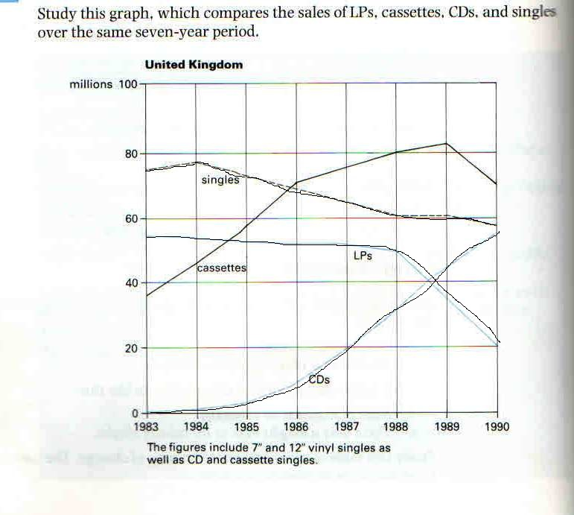

- Write in words these expressions:

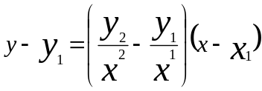

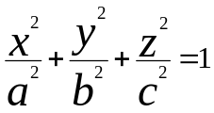

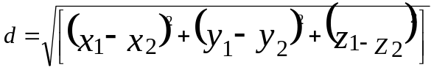

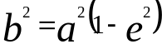
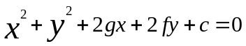

- Identify an object in the classroom and describe it in terms of its geometrical shapes and bodies, approximate dimensions, material:

